EXP NO: 11 CHANGE HARDWARE COMPATIBILITY OF A VM (EITHER BY CLONE/CREATE NEW ONE) WHICH IS ALREADY CREATED AND CONFIGURED, USING VIRTUAL BOX.

AIM:
To create a snapshot of a vm and test it by loading the previous version/cloned vm

PROCEDURE:
STEP 1: GOTO VMWARE WORKSTATION. STEP 2: CREATE FILES ON DESKTOP.
STEP 3: CLICK ON VM AND SELECTS SNAPSHOT-> TAKE SNAPSHOT.
STEP 4: SNAPSHOT IS BEING DONE

IMPLEMENTATION
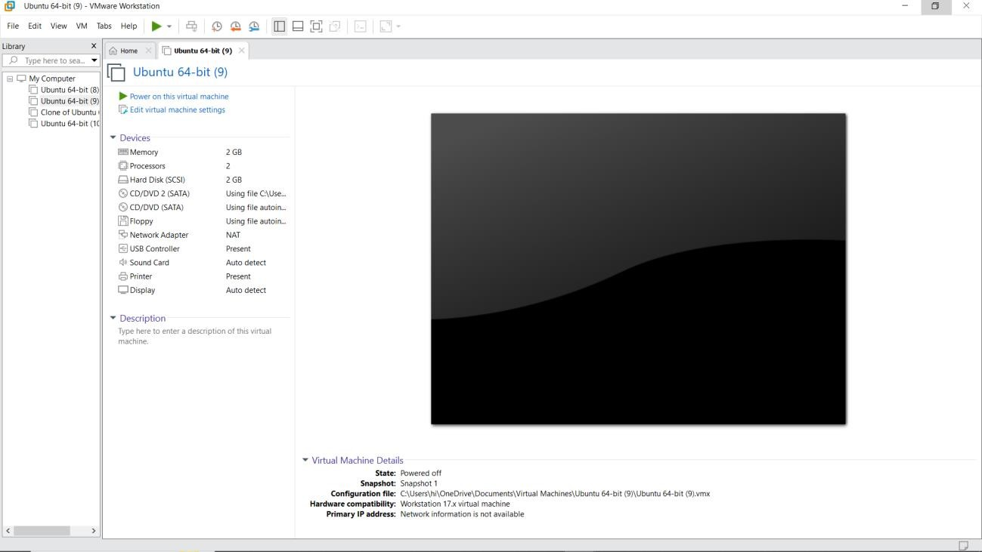

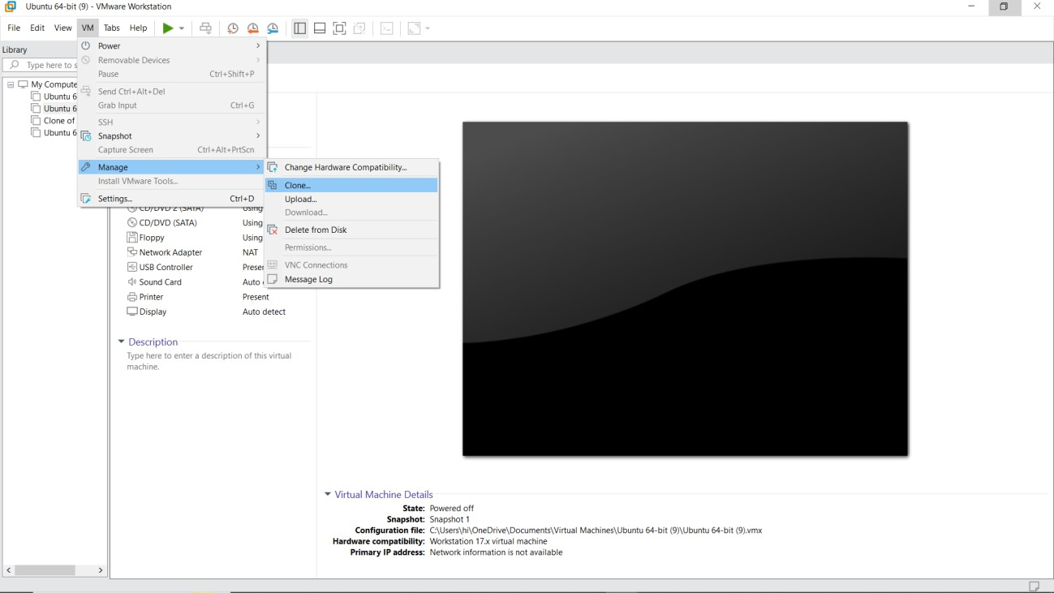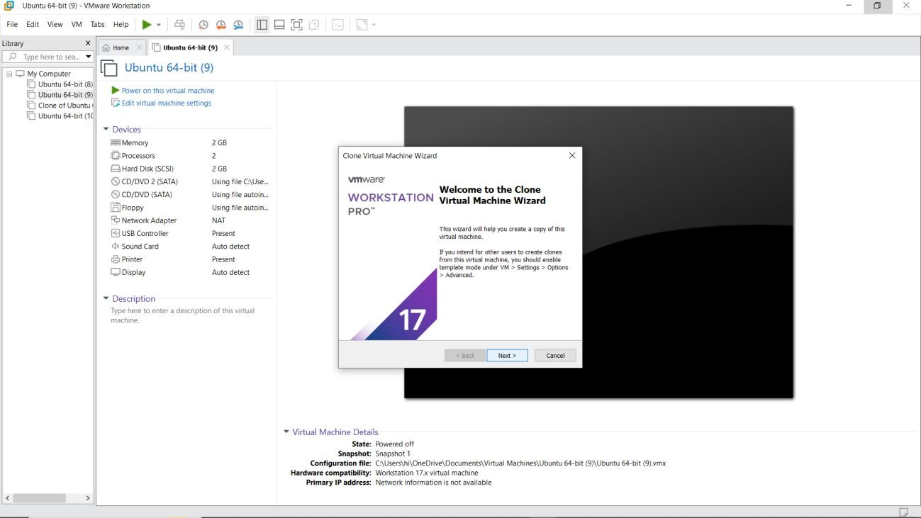

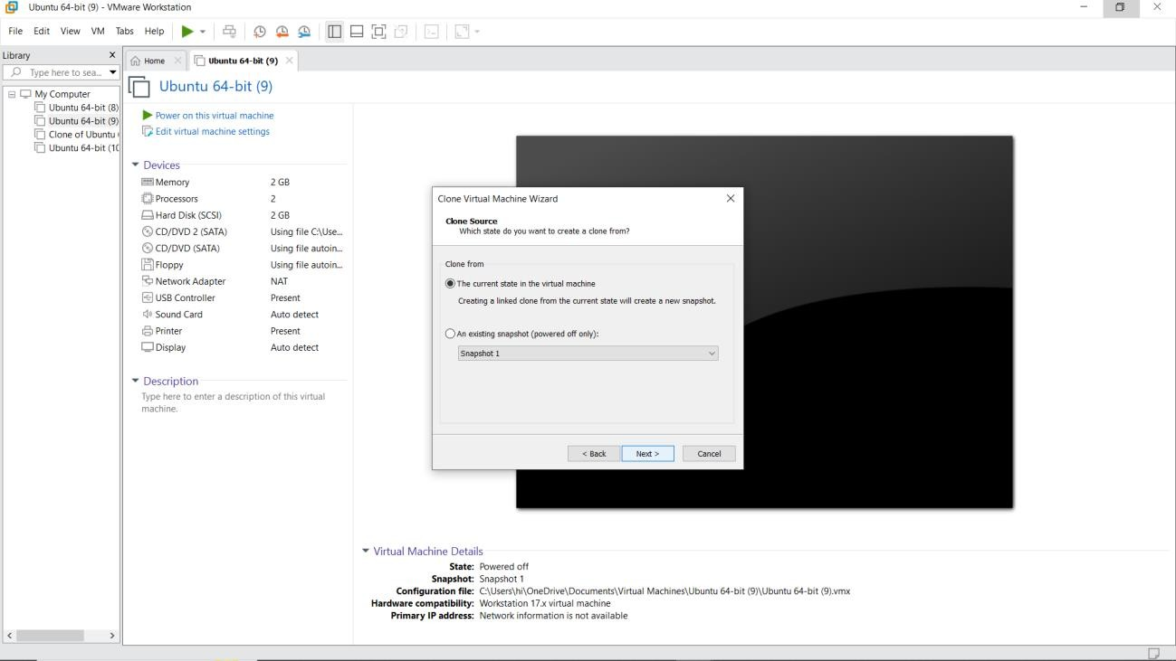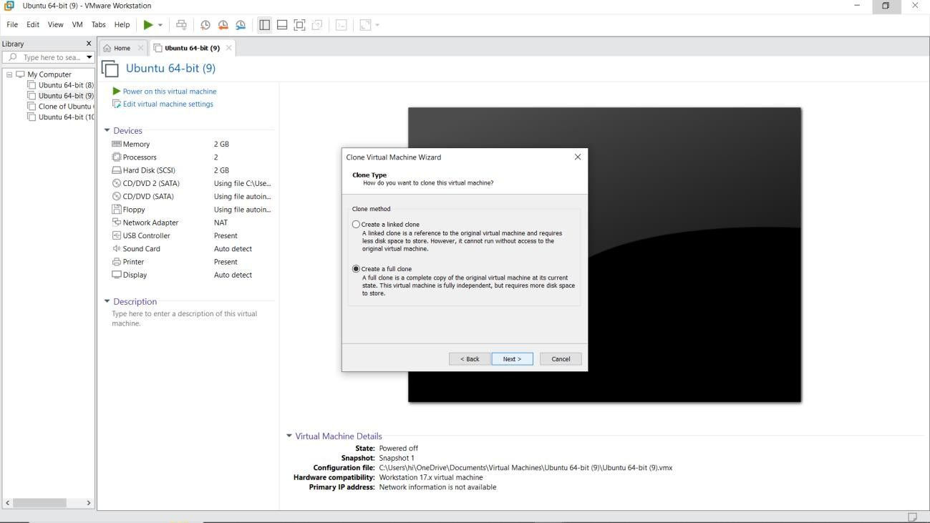

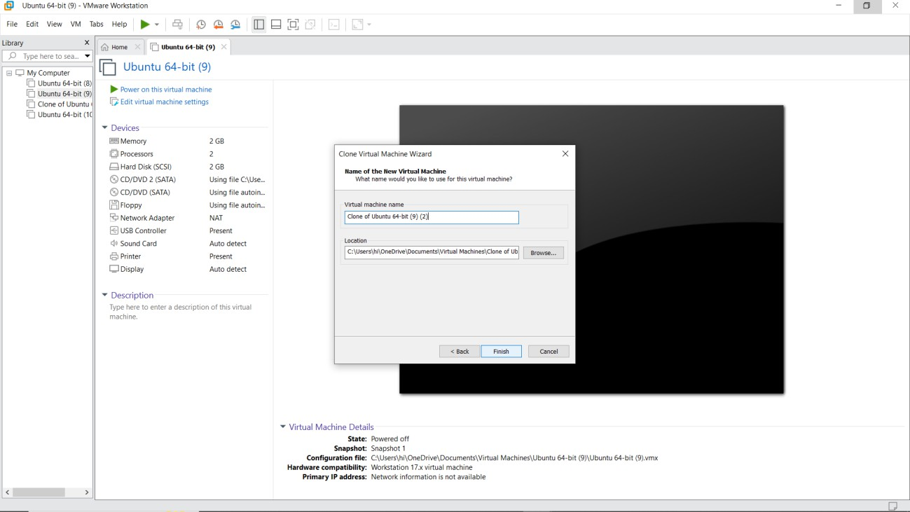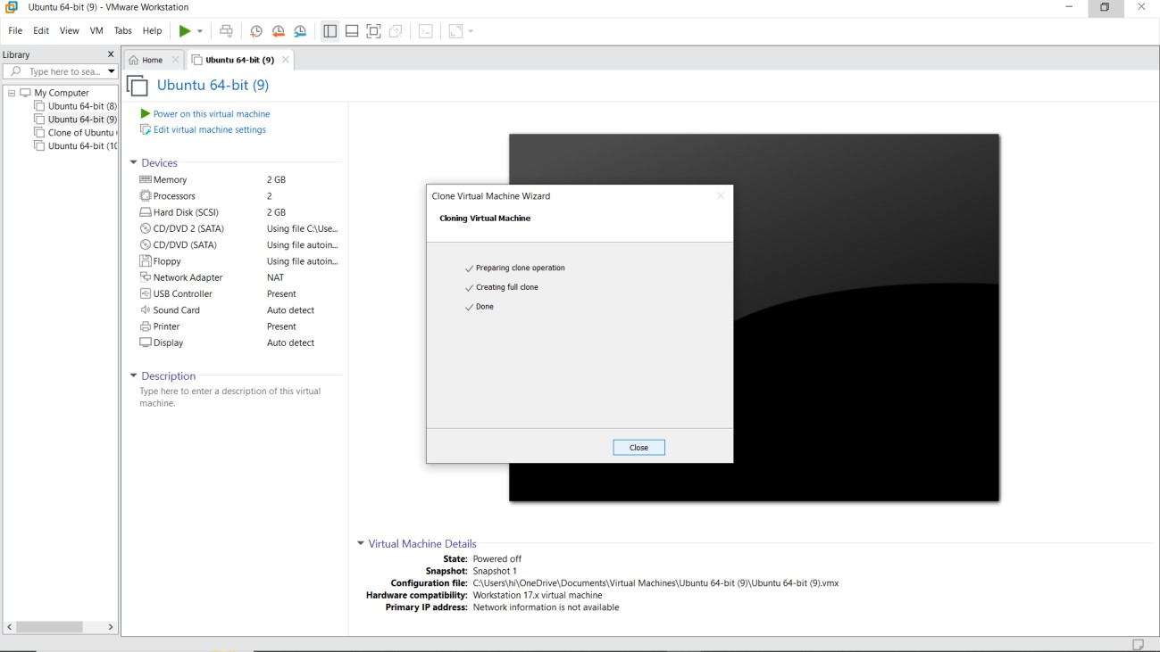

RESULT:
A snapshot of a vm and test it by loading the previous version/cloned vm has been created.

